Lab Assignment-6 Tanvi Penumudy E18CSE187

Index:

1. Page 1: Question 1 (Code)
2. Page 2: Question 1 (Waveform)
3. Page 3: Question 2 (Code)
4. Page 4: Question 2 (Waveform)

Question 1 (Code) :

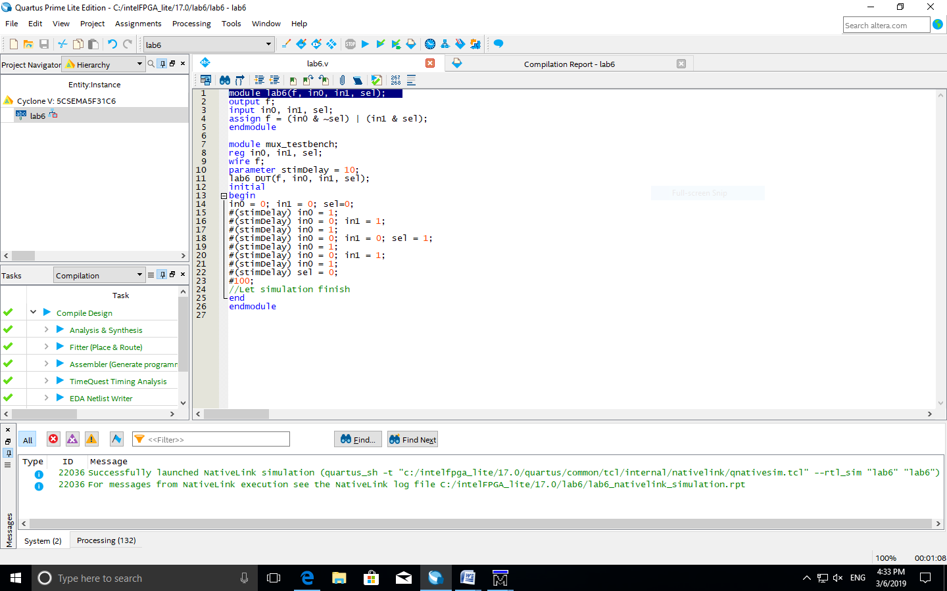

Question 1 (Waveform) :

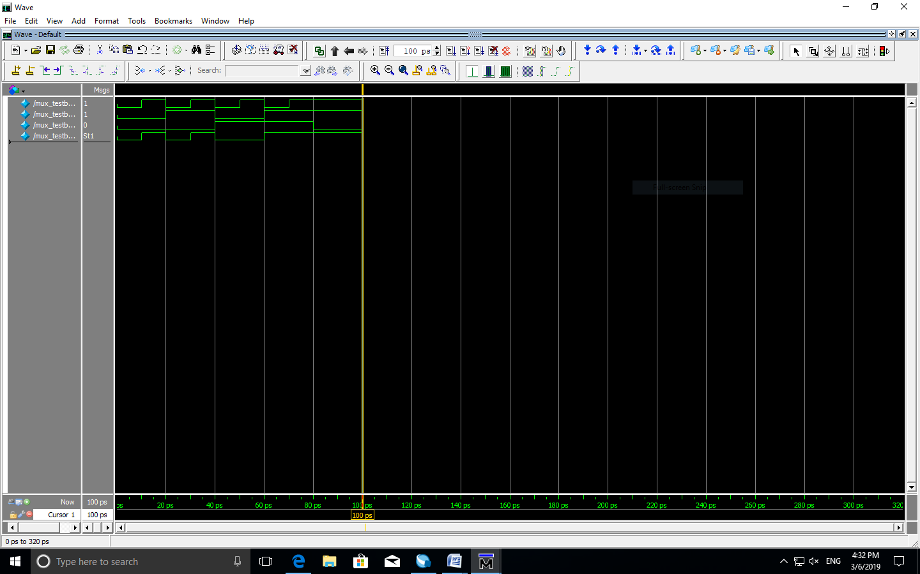

Question 2 (Code):

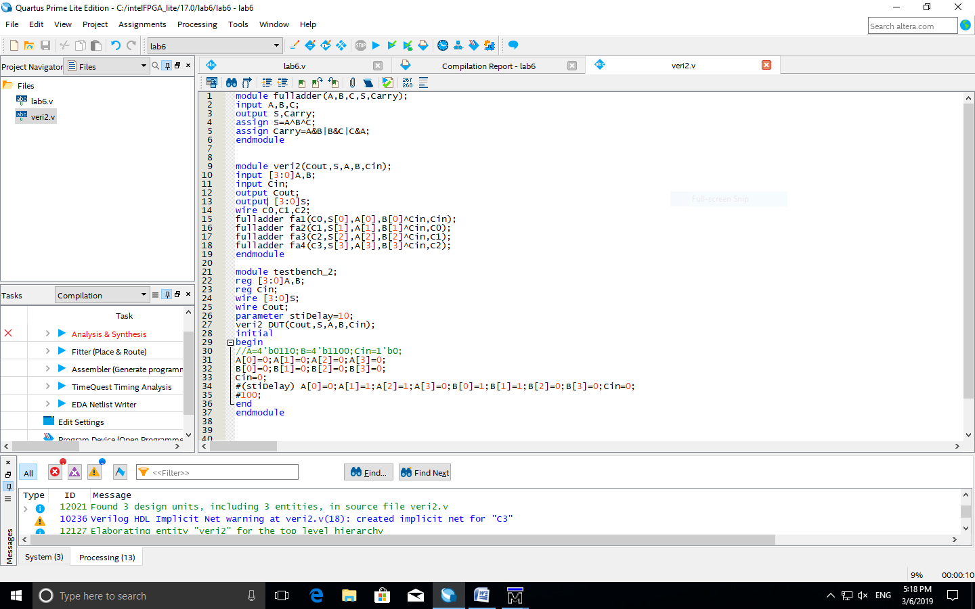

Question 2 (Waveform):

